"Collector's Voice" Newsletter
¯¯¯¯¯¯¯¯¯¯¯¯¯¯¯¯¯¯¯¯¯¯¯¯¯¯¯¯¯¯¯¯¯¯¯¯¯¯¯¯¯¯¯¯¯¯¯¯¯¯¯¯¯¯¯¯¯¯¯¯¯¯¯¯¯¯¯¯¯¯¯¯¯¯¯¯¯
FOR COLLECTORS, ENTHUSIASTS, AND FRIENDS OF V-M CORPORATION AND ITS PRODUCTS
_____________________________________________________________________________

Vol. 5. No. 4. www.thevoiceofmusic.com October, 2000

Published by Gary Stork four times a year (January, April, July, and October).
-----------------------------------------------------------------------------

V-M Collector's Voice Newsletter
37530 E. Meadowhill
Northville, MI 48167-8915

-----------------------------------------------------------------------------

FROM THE EDITOR ....

With this edition of the V-M Collector’s Voice Newsletter, we celebrate 5 years. The first issue in January of 1996 seems so long ago now, and by the nature of this fast paced modern life, events seemly have increased the distance. Consider that no one had heard of ebay.com in 1996 because it had not yet been invented. The internet itself was still in its infancy. V-M Corporation was still operating out of 305 Territorial, and I had no clue that with a little help from my friends, we would stage Operation Rescue ’98 to save what we could of parts, service manuals, owner’s manuals, and historical documentation of all kinds from V-M Corporation itself. The best thing about this past five years has been the friends I have made and the interest they have shown in keeping the old record players and tape recorders going! Let me tell you - there are a lot of V-M “audio enthusiasts” out there! Here’s another example of a note that I got recently from Michael Rubano. This response came after I specified (by V-M part number) all belts he needed to restore a Model 730 tape recorder:

Wow! Talk about service after the sale! I wish it was this easy to obtain parts for more "modern" equipment. I rarely buy new audio/video equipment because it just doesn't hold up even under delicate usage. Don't try to buy your own parts and manuals for the new stuff - you'll need an attorney to prove you won't sue if you happen to make the wrong diagnosis. That's if you can find a retail parts outlet in the remote, desolate area of Chicago, IL Why not just resume production at VM? I'd buy a VM CD changer in a minute. Then, maybe a VM VCR, possibly a VM CD for my car or a portable CD... My Dyna home gear is nearing forty years of age. How about some nice tube based high end kits? It's all the rage these days and I've always preferred tube gear. It's all I have. Just don't leave out the phono stage. Oh, well, enough rambling. I'm going to drop a check in the mail within the next couple of days for the "soft" parts for my 730. I might go for the manual at a later time. Thanks for your help and quick response.

Helping all these people out is rewarding and a lot of fun. It is however, taking up more time! So I am faced with a conundrum - the Newsletter is helping to fuel this success by stimulating interest in V-M products, and yet it is taking time that I could be using to organize and make more parts available to people who need them. My “day job” is also increasingly demanding, and I love spending time with my 4 year old who increasingly wants to “help out” with all operations here at V-M Audio Enthusiasts (some of you may have ordered recently and wondered why the part numbers stamped on the envelopes are blurry - my young apprentice at work!). Her help is welcome, but as you can imagine, I can get more done faster alone at this point! After weighing all of these factors, I have decided to suspend publication of the Newsletter indefinitely. I will partially use the time savings to continue to capture interviews with ex-V-M employees. The ongoing march of time will not permit me to postpone this gathering of memories and historical information for very long! So - who knows, if I get the itch to write, an edition could pop up at www.thevoiceofmusic.com at any time, but I am making no promises at this point. Prior editions (1996-1999) are available as hardcopies. The 1996-1998 issues are longer, 8 to 10 pages each, and are $5.60 per year (my cost). 1999 issues are same format as 2000, and $2.00 (my cost) will cover it. Just send a check to Gary Stork at the Newsletter address. To all of those who have been with me during that pre-Internet era of Newsletter publication, I say thank you.

Wedding Bells - I recently had the good fortune to be invited to V-M Corporation President Victor Miller’s 50th wedding anniversary!!! Victor and wife Tenny Miller were there with about 100 family members and friends. After arriving in a 1950 Studebaker, the Miller’s greated people, sat down to a catered dinner, with dancing and socializing afterwards. All under a big tent on a gorgeous evening just a stone’s throw away from Lake Michigan. There were some ex-V-M employees and their spouses there too - Dick Weber, Mercer Fisher, Ken Voyles, Jim Reeves - all people that have appeared in past issues of this Newsletter. I also met some that I hope to catch up with for future interviews - John and Martha Huizinga, Al Ratter, Lou Stelter and Doug Smith. Two other special encounters also happened - I got to meet Victor’s brother Stanley Miller, whose New Products Corporation made many of the zinc die cast parts for V-M Corporation, including the upper frame in the record changers. I will also mention that New Products Corporation (NPC) produced the first record changers (the Erwood model) in Benton Harbor, from 1940 until civilian goods production ceased in 1942. Stanley was there full time as record changer production started. He was primarily focused at that time on perfecting NPC skills in aluminum die casting, plus some brass and magnesium die casting too. V-M Corporation was formed in June of 1944, and picked up all record changer manufacture from NPC after the war. I also met Roni Erichsen, formerly Roni Gaarder, who is the daughter of Kjell Gaarder, the man most responsible for design of the first V-M Model 700 tape recorder. I told her on behalf of all of you that these machines are out there in service every day - still “pleasure’s new sound”! She was quite thrilled to hear it. Everyone enjoyed (and photographed profusely) watching Victor and Tenny as they cut the wedding anniversary cake, which quickly fanned out and was enjoyed by all. The DJ began to play music, but our time was up. So with the sun beginning to set over the lake, my wife and family departed to make the 3 hour trek back to metro Detroit, although none of us really wanted to leave.
Restoration Tips - How to Replace a Turntable Mat
Many times, a changer in otherwise excellent shape comes to your attention with a loose, floppy mat that needs regluing. Perhaps the mat is still glued down, but is all stained or scratched and you wish to replace it with a new one from V-M Audio Enthusiasts. For either of these situations, your satisfaction with the final result will depend on how well the mat is fastened to the platter - flat, without bumps or waviness. This bit of advice comes from Joel Thorner- whose hobby-turned-business involves the sales and service of vintage and classic record playing systems. Check out his website at www.theturntablefactory.com! Joel recommends:

As far as the mats, it depends on the composition. Generally, I use lacquer thinners or acetone to get the glue off the platter, then a light sanding (but not to the edge). Some mats, I take regular rubber cement, brush it on evenly both mat and platter, wait 15 minutes, then stick together. Works as well as contact adhesive (which I don't use, as sometimes it reacts with the rubber/plastic mat). The other option is 3M Trim Adhesive, which comes in a spray can and is made for auto use. It uses more solvents than rubber cement, but if you use a light enough coating on both surfaces, it may hold a bit better than rubber cement too. Same rule, though - apply to both surfaces and wait 15 minutes. The more even you get the coatings, the better the job will turn out. I'd try some dabs of these glues on a junk surface before recommending any method. Sometimes, I've found that thinners will misshape the mat for a day, but it will eventually come back to proper shape. Have found that more in Garrards than with mats from other brands. I have a feeling that either of my 2 methods will be good for VM mats, if prepped right (and masked where necessary). Hope that helps!! Joel

Some Quick Q&A
Here are some of the most common questions I get from people writing in. Thought I would share them along with the answers to help more folks out:

Q: The back of my phono (or amplifier) requires a special two-pronged speaker plug. Do you have one?

A: This arrangement was common on V-M products of the 1950’s through mid-1960’s when they switched to either screw type or RCA pin plug arrangements for external speaker hookup. We have a VM 5258 plug and housing that you can use with your own wire, or a VM 15764 adaptor plug that accepts a standard RCA pin plug.

Q: The tape reels on my model (730, 735, 740 etc.) won’t stop quickly when I press STOP and tape spills all over. What’s wrong?

A: First remove the knobs, trim and painted top plate. You will discover that the two brake bands that are supposed to be on the two levers that extend to either reel hub have disintegrated. You will need to order two replacements, part number VM 21122.

Q: I need the little knob that turns the needle from LP to 78 on my Zenith/V-M changer with the floating type cartridge. Can you help?

A: There are several styles of this knob over the years. It is first necessary to find the V-M model number of your changer. Generally, this is located on the underside of the unit. Look for an ink stamped number or a paper tag with a sequence of numbers like “EIA 857 6312 1245 723 ….”. You are looking for the “1245-723” which is the V-M model number in the above example. If your changer has the paper tag instead of the ink stamping, the model number will be in large red print in the center of the tag. From that, I can determine the correct V-M part number of the knob and look to see if I have it.
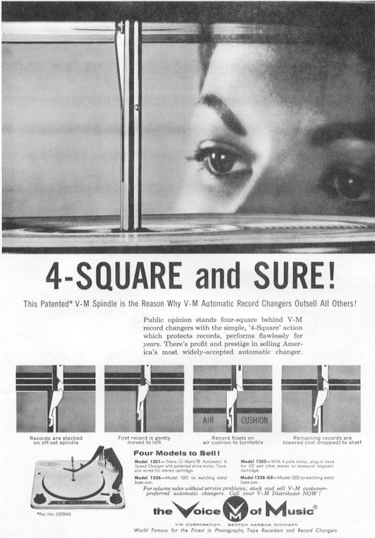

The purpose of the V-M Collector's Voice Newsletter is to foster interest in collecting and restoring V-M products, and to preserve the memory of V-M Corporation's role in audio history. The Newsletter is available free at www.thevoiceofmusic.com. Inquiries can also be made regarding back issue availability. Written material from subscribers is actively solicited and greatly appreciated! All material is verified with the originator before published. Mistakes do happen from time to time, and will be corrected in a subsequent issue.

